**DATABASE MANAGEMENT BASICS**

**Creating tables:**

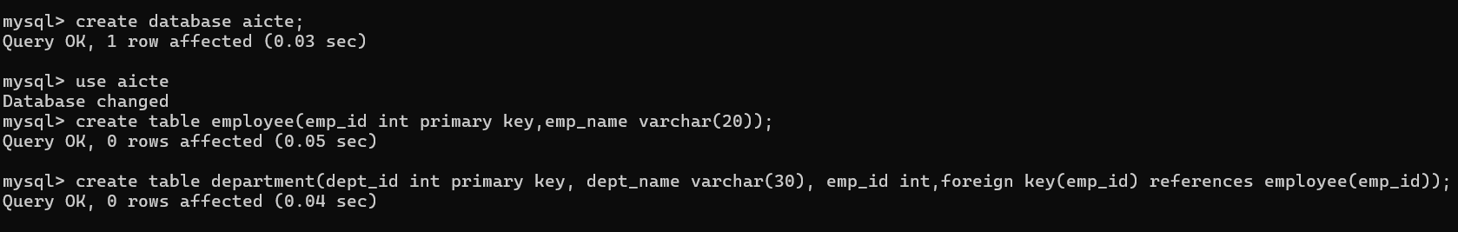

**Data manipulation tasks:**

**Inserting and displaying tables:**

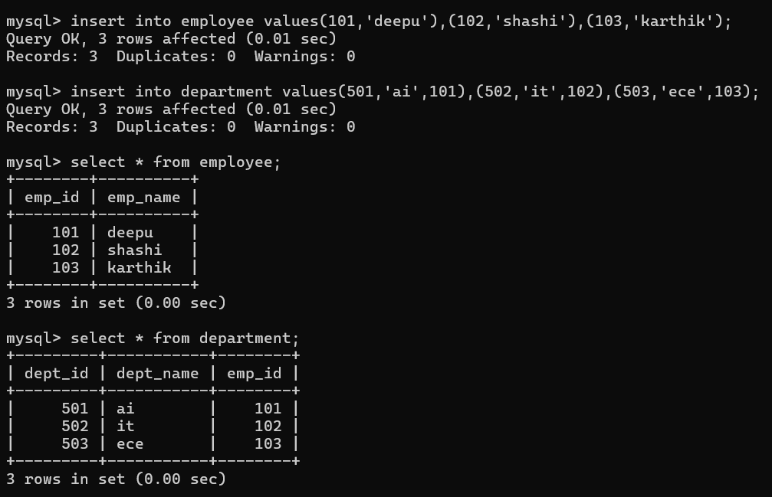

**Updating:**

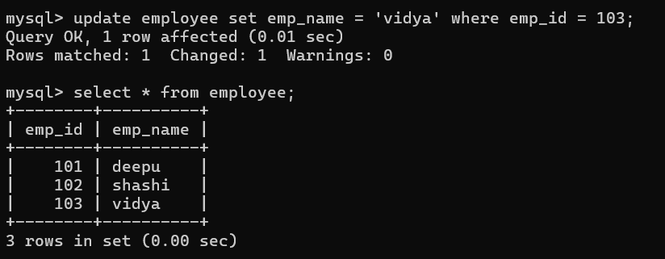

**Deleting:**

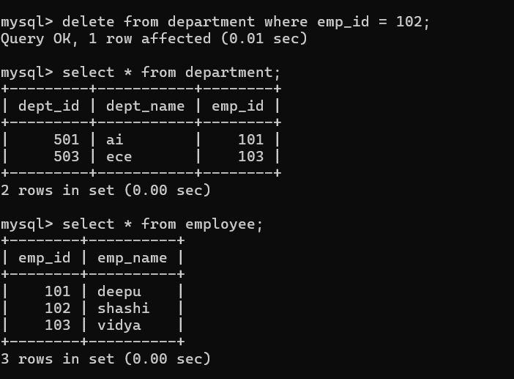

**Database indexing and optimization techniques:**

